
REPUBLIC OF CAMEROON

PEACE-WORK-FATHERLAND
BUEA, SOUTH WEST REGION
TASK 4 REPORT
System Modelling and Design
CEF440: PROGRAMMING AND MOBILE PROGRAMMING

UNIVERSITY OF BUEA

FACULTY OF ENGINEERING AND TECHNOLOGY
(FET)

By:
GROUP 4 MEMBERS

COURSE INSTRUCTOR:

DR NKEMENI VALERY

Name | Matri cule
AKO JUNIOR NGOH | FE23A008
ETUMA ELKINGS BOSANGO | FE23A053
MOUKAM HAKO BELLAMY STEVE | FE23A096
NJIKANG BRIGHT NDODE NGONE | FE23A115
RINGNYU MBUNWE GIYOH LEMUEL | FE23A136
Table of Contents
Introduction 2
1. CONTEXT DIAGRAM 3
1.1 Overview 3
1.2 External Entities 3
1.3 Diagram 4
1.4 Data Flow Description 4
1.5 Level 0 Data Flow Diagram (DFD) 5
1.5.1 Overview 5
1.5.2 Diagram 5
1.5.3 Data Flow Description 5
1.6 Level 1 Data Flow Diagram 6
1.6.1 Overview 6
1.6.2 Internal Processes 6
1.6.3 Data Stores 7
1.2.4 Diagram 7
1.6.5 Complete Data Flow Description 8
1.7 Summary 9
2. USE CASE DIAGRAM 10
2.3.1 Group A: Subscriber Core Functions (UC1–UC6, UC10) 12
2.3.2 Group B Background Data Collection, OS-Driven (UC7–UC9) 14
2.3.3 Group C Data Management & Compliance (UC10–UC13) 14
2.3.4 Group D Reporting & Analytics (UC14–UC17) 15
2.3.5 Group E System Sub-Functions (<<include>>) 16
2.3.6 Group F Extension Points (<<extend>>) 16
2.4. Use Case Relationships 17
2.4.1 Association (Solid Line) 17
2.4.2 <<include>> (Dashed Arrow, Open Arrowhead) 17
2.4.3 <<extend>> (Dashed Arrow, Open Arrowhead) 17
2.5. Requirements Traceability 18
2.6. Conclusion 20
3.1 Overview 21
3.2 System Actors and Components 21
3.2.1 User 21
3.2.2 Mobile App 21
3.2.3 Background Service 21
3.2.4 SQLite Database 21
3.2.5 Remote Server 21
3.3. Sequence Diagram Flows 23
3.3.1 Flow 1: Application Launch and Initialisation 23
3.2.2 Flow 2: Periodic Background Metric Collection 23
3.3.3 Flow 3: User Satisfaction Prompt and Feedback Logging 24
3.3.4 Flow 4: Real-Time Dashboard Display 24
3.3.5 Flow 5: Offline Data Synchronisation 25
3.3.6 Flow 6: Active Speed Test 26
3.4. Key Design Decisions Reflected in the Diagram 27
3.4.1 Offline-First Architecture 27
3.4.2 Consent-Gated GPS Collection 27
3.4.3 Background Execution Strategy 27
3.4.4 Prompt Frequency Enforcement 27
3.5 Security 27
3.6. Requirements Traceability 27
3.7 Conclusion 28
4. Class Diagram Analysis Report 28
4.1. Overview 28
4.2. Core Components and Logic 28
4.3. Technical Constraints and Feasibility 29
5. TECHNICAL DEPLOYMENT AND SYSTEM DEPENDENCY REPORT 30
5.1 System Architecture Overview 30
5.2 Node configurations (what is inside each device) 31
5.2.1 Node 1: Android Smartphone (OS 10+) 31
5.2.2 Node 2: Apple iPhone (OS 16+) 31
5.2.3 Node 3: Cloud Application Server 32
5.2.4 Node 4: Central Telemetry Database Server 32
5.3 Database Tables: 33
5.3.1 System connection protocols (how nodes communicate) 33
5.3.1.1 Connection 1 (Mobile Devices to Cloud Application Server) 33
5.3.1.2 Connection 2 (Cloud Application Server to Database Server) 33
5.3.1.3 Connection 3 (Stakeholder Dashboards to Cloud Application Server) 33
5.3.2 Internal component dependencies (how the app parts work together) 34
5.3.2 Real-world system constraints 34

Introduction
System Modelling and Design is the phase in software engineering where abstract requirements are transformed into concrete, implementable blueprints. Having established in Task 2 what the system must do through surveys, brainstorming, and reverse engineering, and having rigorously analysed, prioritised, and validated those requirements in Task 3, this phase answers the next critical question which is how exactly will the system be built?
The QoE Mobile Network Monitoring Application is a non-trivial system. It must operate silently in the background on two distinct mobile platforms, collect sensitive network and location data under strict privacy constraints, survive periods of complete network absence and recover without data loss, deliver real-time value to individual subscribers while simultaneously feeding accumulated intelligence to telecom operators, and do all of this without meaningfully draining the user's battery or mobile data. No single diagram or model can capture that complexity in full. This is why system modelling employs multiple complementary views, each demonstrating a different dimension of the architecture.
This report presents six formally structured system models, each selected for a specific purpose. The Context Diagram defines the system boundary and identifies every external entity the system interacts with. The Level 0 Data Flow Diagram opens the system and reveals its major internal processes and the data flows connecting them. The Use Case Diagram reframes the system from the actor's perspective, mapping every interaction a subscriber, operator, engineer, or automated process can have with the system. The Sequence Diagram traces the precise message-by-message execution of the core system workflow, from the moment a user opens the app through to data collection, local storage, quality evaluation, push notification, and backend synchronisation. The Class Diagram defines the object-oriented structure of the codebase, specifying every class, its attributes, its methods, and its relationships with other classes. Finally, the Deployment Diagram maps all software components to their physical infrastructure, specifying the hardware nodes, communication protocols, and security mechanisms that will host the live system.Every design decision documented in this report is based on the validated requirements we got from Task 3 and taken together, the six models produced in this report form a complete, internally consistent, and fully traceable system design that the development team can carry directly into implementation.

1. CONTEXT DIAGRAM

1.1 Overview
The Context Diagram represents the QoE Mobile Network Monitoring Application as a single, atomic process surrounded by all external entities that interact with it. At this level of abstraction, no internal detail is shown; the focus is entirely on the system’s boundary and its interfaces with the outside world. The diagram answers the fundamental question of who or what interacts with the system, and what data is exchanged?

1.2 External Entities
Four external entities were identified from the SRS stakeholder analysis:

Entity | Type | Interaction with system
Mobile User (Subscriber) | Primary user | Provides feedback and settings, receives live dashboard and push alerts.
GPS / OS APIs | Platform interface | Supplies raw network signal data and GPS location to the application.
Backend Server (REST API) | External server | Receives uploaded metric batches and QoE ratings; returns historical records.
Telecom Operator (MTN, Orange, CAMTEL) | Secondary consumer | Receives aggregated network coverage reports generated by the backend.
Table 1: External entities in the context diagram

1.3 Diagram
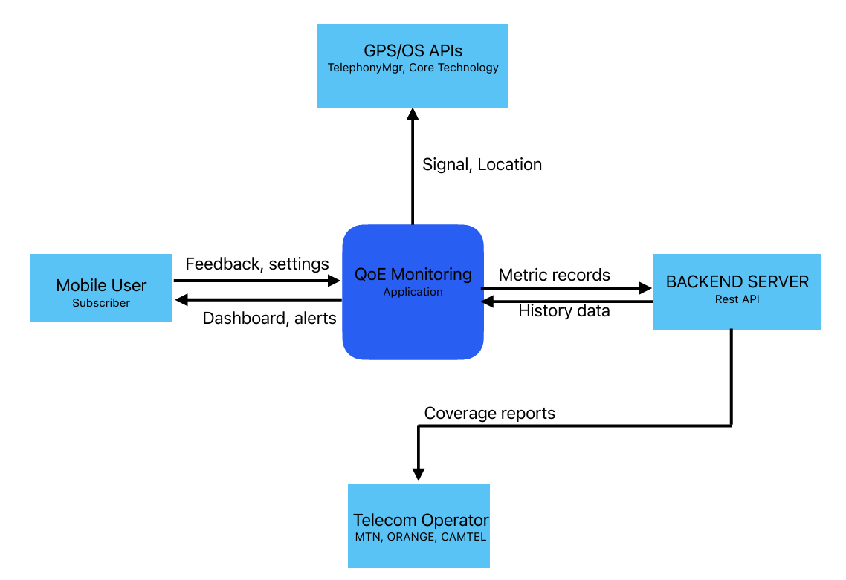Figure 1, Context Diagram: QoE Mobile Network Monitoring Application

1.4 Data Flow Description
The following flows cross the system boundary:
- GPS / OS APIs to System: Raw network signal metrics and GPS location coordinates are fed continuously into the application via platform APIs (TelephonyManager on Android, CoreTelephony on iOS).
- Mobile User to System: The subscriber provides QoE feedback ratings and adjusts application settings including notification thresholds and data collection preferences.
- System to Mobile User: The application returns the live network performance dashboard and delivers push notifications when quality drops below configured thresholds.
- System to Backend Server: Batched metric records and QoE ratings are uploaded to the backend REST API over HTTPS.
- Backend Server to System: Aggregated historical performance records are returned to the application on request.
- Backend Server to Telecom Operator: The backend generates and forwards network coverage reports to telecom operators for infrastructure planning.

1.5 Level 0 Data Flow Diagram (DFD)

1.5.1 Overview
The Level 0 DFD expands the context diagram by introducing a system boundary while still representing the application as a single high-level process. It retains the same four external entities from the context diagram but adds explicit representation of the system boundary and refines the data flow labels to be more precise. This diagram serves as the bridge between the context level and the fully decomposed Level 1 DFD.

1.5.2 Diagram
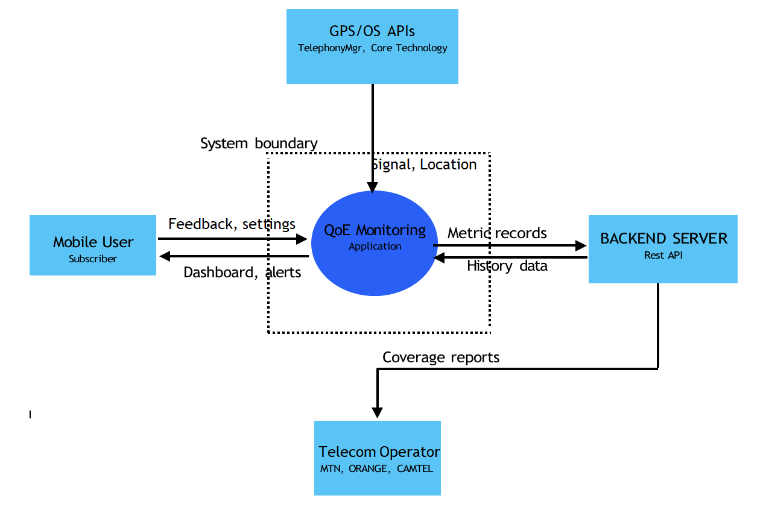Figure 2, Level 0 DFD: QoE Mobile Network Monitoring Application

1.5.3 Data Flow Description
At Level 0 the same six data flows from the context diagram are present but described with greater specificity:
- Network data, location to Process 0: The application receives real-time cellular signal measurements (RSRP, RSSI, SINR on Android; network type on iOS) and GPS coordinates from the device operating system.
- Feedback, settings to Process 0: The mobile subscriber supplies star-rated QoE feedback and configuration preferences through the application interface.
- Process 0 to Dashboard, alerts: The application returns a real-time metrics display and OS-level push notifications to the subscriber.
- Metric batch, ratings to Backend Server: Compressed and timestamped metric records, together with QoE ratings, are uploaded as JSON payloads over TLS 1.2+ to the backend REST endpoint.
- History records to Process 0: The backend returns the authenticated user’s historical aggregated records for display in the performance history screen.
- Backend Server to Telecom Operator: The backend aggregates data from all participating devices and forwards coverage reports for network optimization.

1.6 Level 1 Data Flow Diagram

1.6.1 Overview
The Level 1 DFD decomposes the single ‘Process 0’ from the Level 0 DFD into five distinct internal processes. Each process corresponds to a coherent group of functional requirements identified in the SRS. Three data stores are introduced to represent local persistence on the device. This diagram provides the most detailed view of the system’s internal data flow architecture in this report.

1.6.2 Internal Processes
The five processes and their corresponding SRS functional requirements are listed below:

ID | Process name | SRS requirement(s) | Responsibility
P1 | Collect metrics | FR-01 | Receives raw signal and location data from GPS/OS APIs and writes timestamped metric records to DS1.
P2 | Display dashboard | FR-02, FR-09 | Reads current metric readings from DS1 and renders the live dashboard for the mobile user.
P3 | Send notifications | FR-03 | Monitors metric values from DS1 against configured thresholds and dispatches push alerts to the mobile user when a breach is detected.
P4 | Collect feedback | FR-05 | Accepts QoE star ratings entered by the mobile user and writes them to DS2 for later upload.
P5 | Sync data | FR-08 | Reads queued metric records from DS1 and feedback from DS2, stages them in DS3, then transmits the batch to the backend server when connectivity is available.
Table 2, Level 1 internal processes

1.6.3 Data Stores
Three on-device data stores manage local persistence:
- DS1, Local metrics DB: The primary SQLite database that stores all timestamped metric records collected by P1. It serves as the source of truth for both the dashboard (P2), the notification engine (P3), and the sync process (P5). This store supports the offline-first requirement (FR-08) and the 7-day retention policy specified in PR-07.
- DS2, Feedback store: Holds QoE star ratings written by P4 (Collect feedback) until they can be uploaded. Feedback records are read by P5 and included in the next sync batch.
- DS3, Upload queue: A staging store written by P5 that holds the assembled batch of metric records and feedback ratings immediately before transmission to the backend server. This decouples batch assembly from network transmission and supports the exponential back-off retry logic described in NFR-06.

1.2.4 Diagram
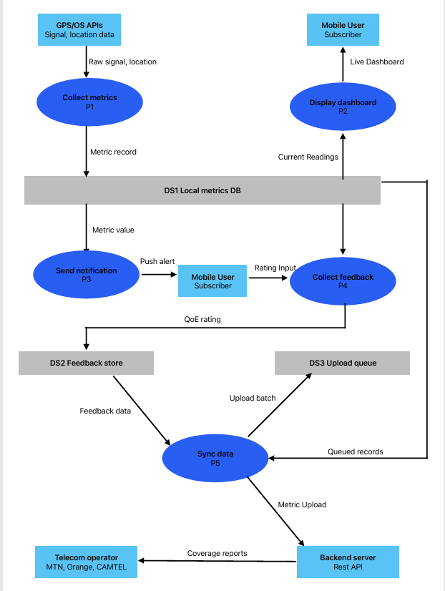
Figure 3, Level 1 DFD: QoE Mobile Network Monitoring Application

1.6.5 Complete Data Flow Description
The numbered flows below trace all data movements in the Level 1 DFD from top to bottom:

- GPS/OS APIs to P1 (Raw signal, location): The device operating system delivers real-time cellular metrics and GPS coordinates to the Collect Metrics process every 60 seconds by default (configurable between 30 and 300 seconds per PR-01).
- P1 to DS1 (Metric record): Each timestamped metric record is persisted immediately to the Local Metrics DB. Records are stored locally first to guarantee zero data loss during connectivity interruptions (NFR-06).
- DS1 to P2 (Current readings): The Display Dashboard process polls DS1 every two seconds while the app is in the foreground (PR-01) and retrieves the latest readings to refresh the live dashboard.
- P2 to Mobile User (Live dashboard): The updated signal strength, download and upload speed, latency, network type, and data usage counter are rendered on the home screen for the subscriber.
- DS1 to P3 (Metric value): The Send Notifications process reads the latest metric values from DS1 and compares them against the thresholds configured by the user.
- P3 to Mobile User (Push alert): When a threshold breach is detected, an OS push notification is dispatched within five seconds on Android, or within the next background fetch cycle on iOS (PR-02).
- Mobile User to P4 (Rating input): When prompted, either by a network event or a scheduled timer, the subscriber submits a 1–5 star QoE rating for overall satisfaction and speed perception.
- P4 to DS2 (QoE rating): The submitted rating, together with an optional free-text comment, is written to the Feedback Store for asynchronous upload.
- DS2 to P5 (Feedback data): The Sync Data process reads all pending feedback records from DS2 and includes them in the next upload batch.
- DS1 tot P5 (Queued records): P5 also reads all unsynced metric records from DS1 for inclusion in the upload batch.
- P5 to DS3 (Upload batch): The assembled batch is staged in the Upload Queue store before transmission, enabling retry without re-reading from DS1 or DS2.
- P5 to Backend Server (Metric upload): On connectivity restoration, P5 transmits the staged batch to the backend via a POST /metrics request over HTTPS. Upload of up to 1,000 records must complete within 10 seconds on a 4G connection (PR-06).
- Backend Server to Telecom Operator (Coverage reports): After aggregating data from all participating devices, the backend produces network coverage and performance reports delivered to telecom operators for infrastructure planning.
Worth noting that
FR: Functional requirements, NFR: Non-functional requiremets, DS: Data stores , P is for a process

1.7 Summary
This report has presented the three data flow diagrams that define the system architecture of the QoE Mobile Network Monitoring Application at increasing levels of detail. The table below summarizes the purpose and key components of each diagram.

Diagram | Level of abstraction | Key components
Context Diagram | Highest (system as black box) | 4 external entities, 6 top-level data flows, system boundary.
Level 0 DFD | Intermediate | 4 external entities, 1 system process (Process 0), explicit system boundary, refined flow labels.
Level 1 DFD | Detailed | 4 external entities, 5 internal processes (P1–P5), 3 data stores (DS1–DS3), 13 labelled data flows.
The diagrams collectively demonstrate that the QoE application handles data through a well-defined pipeline, raw network data enters through platform APIs, is processed and stored locally, surfaced to the user in real time, enriched with subjective feedback, and synchronized to a backend server for aggregated analysis. All functional requirements from FR-01 to FR-10 identified in the SRS are traceable to at least one process in the Level 1 DFD.
These diagrams will be used as the primary reference for the system implementation phase and complement the use case, sequence, activity, and deployment diagrams produced by the rest of the team.

2. USE CASE DIAGRAM

2.1 Overview:
A Use Case Diagram is a UML (Unified Modelling Language) behavioural diagram that captures, in a single visual, the complete set of functional interactions between the system and everything outside it and it’s actors. Each ellipse in the diagram represents a use case, a discrete unit of functionality that the system provides to deliver value to at least one actor. Each line connecting an actor to a use case represents an association that actor can initiate or participate in that functionality.
Use Case Diagrams answer a question that is fundamental before any code is written: "Who uses this system, and exactly what can they do with it?" For this system, that question is non-trivial. The application serves a diverse set of actors simultaneously, human smartphone users, two mobile operating system platforms, three telecom operators, a backend server, and a national regulatory body. Without a use case diagram, the scope and boundaries of the system would remain ambiguous.
The diagram below presents all 24 use cases and 5 actors in full UML notation. Use cases are grouped by functional band (colour-coded and labelled). Actors appear outside the system boundary rectangle on the left (Subscriber, Mobile OS, ART) and right (Telecom Operator, Backend Server) sides. Associations are solid lines; <<include>> and <<extend>> relationships are dashed arrows.

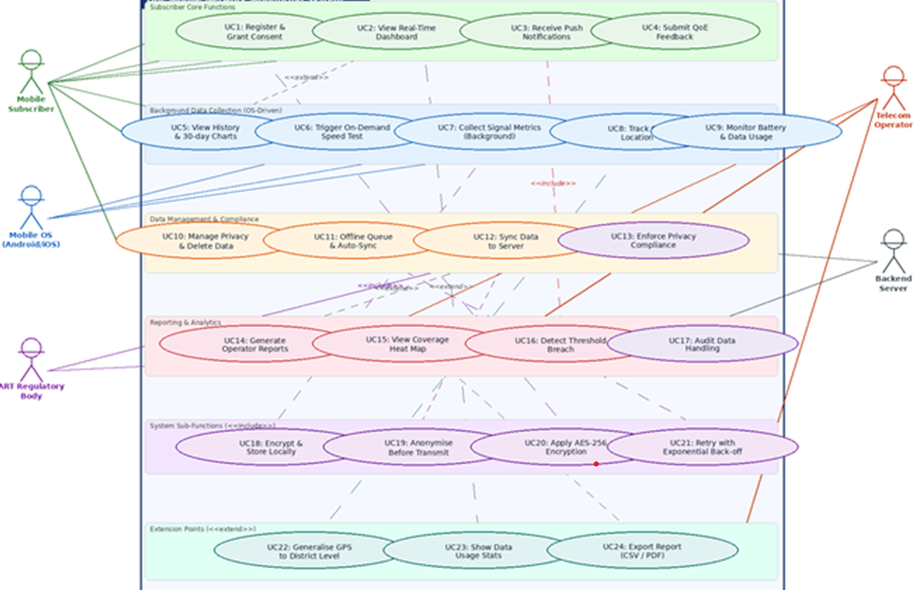 Figure 4, use case diagram: QoE Mobile Network Monitoring Application

2.2 Actors
An actor in UML is any entity that interacts with the system from outside its boundary. Actors can be human users, other software systems, hardware devices, or organizations. The diagram defines five actors, represented as stick figures positioned outside the system boundary rectangle.

No. | Actor | Type | Role in the System
A1 | Mobile Subscriber | Human (Primary) | The human user who installs the app on their smartphone, grants data collection consent, and uses the app's features. The subscriber is the primary beneficiary: they receive the dashboard, notifications, and history charts. They are also the source of crowdsensed data. Without subscribers, there is no data and the system has no value.
A2 | Mobile OS (Android/iOS) | System (Primary) | The mobile operating system (Android 10+ or iOS 16+) provides the sensor APIs the app depends on: TelephonyManager/CoreTelephony for signal data, FusedLocationProvider/CLLocationManager for GPS, WorkManager/BackgroundTasks for periodic background execution, and FCM/APNs for push delivery. The OS is an external actor because the app cannot control its scheduling behaviour.
A3 | Telecom Operator | Human/Org (Secondary) | MTN, Orange, or CAMTEL network operations staff who access the operator-facing portal to view coverage heat maps, KPI dashboards, and QoE reports generated from the crowdsensed data. Operators do not interact with the mobile app directly they interact only with the reporting and analytics use cases on the backend.
A4 | Backend Server | System (Secondary) | The cloud-hosted Node.js/PostgreSQL backend that receives batched metric uploads from mobile devices, stores them, aggregates them, and serves reports to the operator portal. It is treated as an external actor from the mobile app's perspective because it is a separate deployment node communicating over HTTPS.
A5 | ART Regulatory Body | Human/Org (Secondary) | The Agence de Régulation des Télécommunications (ART) of Cameroon, which mandates the legal framework for mobile data collection. ART does not use the app directly; instead, its regulations drive the compliance and audit use cases (UC13, UC17). ART staff can request anonymised data handling audit reports.

Why these five actors and not more? The survey (Task 2) identified four stakeholder categories. The Mobile OS was added as a fifth actor in the use case model because the app's background collection capability is entirely dependent on OS-level APIs and scheduling, ignoring the OS as an actor would misrepresent a critical dependency. The cell tower infrastructure was not included as an actor because the app passively reads signal data without any two-way interaction with the tower hardware.

2.3 Use Cases
The diagram defines 24 use cases, organized into six functional groups. Each group is visually distinguished in the diagram by a lightly shaded band with a group label. The groups represent natural cohesion boundaries, use cases in the same group share a common purpose and are executed in similar contexts.

2.3.1 Group A: Subscriber Core Functions (UC1–UC6, UC10)
These use cases represent the direct, visible interactions that the Mobile Subscriber has with the application. They are the features users consciously choose to engage with, and they were the primary justification cited by survey respondents for installing and keeping a network monitoring app.

UC1: Register & Grant Consent
This is the mandatory first use case for any new installation. The subscriber opens the app and is immediately presented with a consent screen that lists, independently and clearly, what data the app would like to collect such as
(a) background network metrics
(b) GPS location
(c) in-app feedback prompts.
The subscriber toggles each category independently and confirms their choices.
Why this must be a separate, prominent use case? The Task 3 survey found that 68.8% of respondents cited privacy as their primary concern about such an application. Task 3's Non-Functional Requirement NFR-02 also states that a consent screen must appear at first launch, and that each data category must be individually togglable. Making this a first-class use case rather than burying it in a settings menu, this ensures that no data collection can begin before the user has actively seen and responded to the consent request. UC1 includes UC20 (Apply AES-256 Encryption) because the consent preferences themselves are encrypted when stored.

UC2: View Real-Time Dashboard
The subscriber opens the app to see a live display of their current network quality. The dashboard shows: current signal strength (RSRP in dBm, or network type on iOS where raw dBm is unavailable), upload and download speed estimates, round-trip ping latency, packet loss percentage, current network generation (2G/3G/4G/5G), and a "data freshness" timestamp showing when the last reading was taken.
The dashboard refreshes every 2 seconds, reading from a lightweight in-memory metrics cache rather than the SQLite database, to ensure the interface remains responsive. This 2-second UI refresh cycle is deliberately independent of the 60-second background collection cycle a design decision driven by the MVVM architecture recommendation in Task 3. UC2 is extended by UC5 (View History) and UC23 (Show Data Usage Stats), meaning those features add optional capability on top of the dashboard.

UC3: Receive Push Notifications
When the background service detects that a metric reading has crossed a quality threshold, a push notification is sent to the subscriber's device. The notification specifies what degraded (e.g., "Signal strength dropped to -105 dBm") and when it happened, allowing the user to make an informed decision (e.g., move location or switch to Wi-Fi).
Notifications are capped at 3 per day per device. This cap directly resolves Ambiguity I-03 from Task 3's requirement analysis, which noted that the original requirement FR-03 did not specify a frequency limit, making it impossible to implement correctly. The 3-per-day limit balances alerting value against notification fatigue. UC3 is included by UC16 (Detect Threshold Breach), meaning a notification cannot be sent unless a breach has been detected.

UC4: Submit QoE Feedback
After a network event (detected by the background service), the app may prompt the subscriber up to 3 times per day to provide subjective quality feedback. The subscriber rates their experience on a 1-to-5 star scale and can optionally add a free-text comment. This feedback is linked to the specific metric record that triggered the prompt, creating a dataset that correlates objective signal measurements with subjective user experience. This data is invaluable for telecom operators who need to understand how network conditions translate into user perception.

UC5: View History & 30-Day Charts
The subscriber can navigate to a history screen that shows their personal network performance over the past 30 days, rendered as line charts for each metric (RSRP, latency, bandwidth). This is an <<extend>> use case of UC2 it adds optional historical depth to what the dashboard shows in real time. Task 2 identified personal performance history as the single most valued feature among the 93 survey respondents, making this a high-priority use case despite not being part of the background monitoring core.

UC6: Trigger On-Demand Speed Test
The subscriber can manually initiate a speed test from the dashboard at any time. This produces an immediate, active measurement of download and upload bandwidth, complementing the passive background monitoring data. The result is displayed immediately and stored as a metric record. This feature was added to the requirements based on Task 2 survey feedback where users specifically requested "a speed test button."

UC10: Manage Privacy & Delete Data
The subscriber can access a dedicated privacy screen at any time to by: update their consent preferences for any of the three data categories, view a summary of what data has been collected and where it is stored, request complete deletion of their data from both the local device and the backend server. The deletion request triggers both a local SQLite purge and a backend deletion API call, with confirmation returned to the user within the app.
This use case resolves Ambiguity I-06 from Task 3, which noted that the original requirements listed privacy controls without specifying a data deletion mechanism. Under ART Cameroon regulations and international data protection best practices (GDPR-aligned), the right to erasure must be explicitly supported.

2.3.2 Group B: Background Data Collection, OS-Driven (UC7–UC9)
These use cases are initiated and managed by the Mobile OS actor, they run without user action, provided consent has been granted and the OS has not suspended the service. They represent the core crowdsensing functionality of the application.

UC7: Collect Signal Metrics (Background)
Every 60 seconds, the background service reads the following values from OS sensor APIs: RSRP (Reference Signal Received Power), RSSI (Reference Signal Strength Indicator), SINR (Signal-to-Interference-plus-Noise Ratio), current network generation (2G/3G/4G/5G), network operator code, and a timestamp. These values are immediately validated (checked against physical plausibility ranges) and stored in the local encrypted SQLite database.
On Android, this is implemented using WorkManager with a PeriodicWorkRequest, which guarantees periodic execution even after device restart. On iOS, it uses BackgroundTasks (BGAppRefreshTask), which provides best-effort scheduling the iOS scheduler may delay execution based on device usage patterns and battery state. This platform difference is a documented constraint, not a design flaw. UC7 includes UC18 (Encrypt & Store Locally).

UC8: Track GPS Location
When GPS consent has been granted (checked at every execution, not just at app launch), the background service reads the device's GPS coordinates and immediately applies the district-level generalisation transformation (UC22), converting precise coordinates (±50m accuracy) into a district code. The raw coordinates are never stored anywhere only the district code is persisted. This irreversible anonymisation satisfies ART Cameroon's GPS data minimisation requirement and substantially reduces the risk of location-based re-identification of individual users.

UC9: Monitor Battery & Data Usage
The background service continuously tracks its own resource consumption against two strict limits: ≤3% battery drain per hour (NFR-03) and ≤5 MB of mobile data per day (NFR-04). If either limit is being approached, the service automatically extends the collection interval (e.g., from 60 seconds to 120 seconds) until consumption falls back within bounds. The current battery and data consumption figures are surfaced to the user on the privacy/settings screen (UC10), giving full transparency.

2.3.3 Group C: Data Management & Compliance (UC10–UC13)
These use cases handle how collected data is stored, managed, transmitted, and governed. They are initiated by the Mobile Subscriber, Backend Server, and ART Regulatory Body actors.

UC11: Offline Queue & Auto-Sync
When the device has no internet connectivity, a common situation in Cameroon where network coverage gaps are the very problem this app is measuring a collected metric records are held in a persistent offline queue within the encrypted SQLite database. This queue survives app restarts and OS process kills. When connectivity is restored, the sync manager automatically detects the change and triggers UC12. Up to 7 days of data can be queued (approximately 15 MB at nominal collection rates). UC11 includes UC21 (Retry with Exponential Back-off) to handle partial connectivity and transient server errors.

UC12: Sync Data to Server
The sync manager packages queued metric records into batches and uploads them to the backend server via HTTPS with TLS 1.2+ (NFR-01). Each batch upload is acknowledged by the server with a 200 OK response, after which the uploaded records are marked as synced in the local database and are eligible for pruning by the 7-day retention policy. UC12 includes UC19 (Anonymise Before Transmit), ensuring that any residual identifiable data (such as device fingerprints) is anonymised in the upload payload before it leaves the device.

UC13: Enforce Privacy Compliance
This system-level use case, associated with the ART Regulatory Body actor, represents the continuous enforcement of privacy rules throughout the system's operation. It encompasses: verifying that consent is valid before each collection cycle, ensuring that GPS generalisation is applied (UC22), checking that data retention limits are not exceeded, and confirming that only hashed device identifiers appear in the upload payload. This is not a single user action but an ongoing constraint enforced by multiple components.

2.3.4 Group D: Reporting & Analytics (UC14–UC17)
These use cases deliver the crowdsensed network data to the Telecom Operator and serve the ART Regulatory Body's audit requirements. They operate primarily on the backend server.

UC14: Generate Operator Reports
The backend server aggregates uploaded metric records by district code, time period, network generation, and operator, producing structured reports for telecom network operations teams. The reports include: district-level average RSRP/RSSI heat maps, latency percentile distributions, packet loss rates, and QoE feedback score averages. UC14 is an <<extend>> use case of UC12 report generation is triggered by the availability of newly synced data, not by an independent schedule.

UC15: View Coverage Heat Map
Telecom operator staff access a web portal to view interactive geographic heat maps showing network quality by district across Cameroon. The maps are rendered using Leaflet.js with GeoJSON district polygon data. Operators can filter by time period, network generation, and metric type. This use case is extended by UC24 (Export Report as CSV/PDF), which allows operators to download the aggregated data for use in external planning tools.

UC16: Detect Threshold Breach
The notification service evaluates every new metric record against the threshold configuration: RSRP < -100 dBm, latency > 200ms, packet loss > 5%, or bandwidth below the configured minimum. If any threshold is breached, UC16 immediately includes UC3 (Receive Push Notification) to alert the subscriber. The threshold values are configurable constants stored in the ThresholdConfig object, resolving Ambiguity I-02 from Task 3 which identified these values as unspecified in the original requirements.

UC17: Audit Data Handling
ART Cameroon regulators can request an anonymised audit report showing: total records collected per time period, data retention compliance (no records older than 7 days in local storage; archival policy on backend), consent statistics (percentage of users with GPS consent granted vs. declined), and confirmation that raw GPS coordinates are not stored anywhere in the
system. This use case provides the regulatory accountability that gives the system legal legitimacy to operate.

2.3.5 Group E: System Sub-Functions (<<include>>)
These use cases are not initiated directly by any actor. They are included by other use cases meaning they are always executed as a mandatory part of the including use case. They represent shared technical behaviours that are factored out to avoid repetition in the diagram.

- UC18 Encrypt & Store Locally: Included by UC7. Every metric record is encrypted using AES-256 before being written to the SQLite database. This is not optional the database driver is configured to refuse plaintext writes.
- UC19 Anonymise Before Transmit: Included by UC12. The sync manager strips any residual device fingerprint data and replaces all device identifiers with SHA-256 hashes before constructing the upload payload.
- UC20 Apply AES-256 Encryption: Included by UC1. Consent preferences are encrypted when written to storage, using the same key as the metrics database, ensuring that even consent data cannot be read by other apps on the device.
- UC21 Retry with Exponential Back-off: Included by UC11. If a sync upload fails (network error, server error, timeout), the retry manager waits 2^n seconds before the next attempt (2s, 4s, 8s, 16s, up to a maximum of 30 minutes). This prevents overwhelming the backend server during recovery from outages.

2.3.6 Group F: Extension Points (<<extend>>)
Extension use cases add optional or conditional behaviour to a base use case. Unlike <<include>>, extensions are not always executed they run only when certain conditions are met.
- UC22 Generalize GPS to District Level: Extends UC8. When GPS is read, this transformation is always applied, but the use case is separated because its logic (coordinate-to-district mapping using a GeoJSON district polygon lookup) is a distinct, testable operation that may need to be updated independently as district boundaries change.
- UC23 Show Data Usage Stats: Extends UC2. The subscriber can tap an info icon on the dashboard to expand a panel showing how much battery and mobile data the app has consumed in the last 24 hours. This is an extension because most users will not open this panel on every dashboard view.
- UC24 Export Report (CSV / PDF): Extends UC15. Telecom operator staff can choose to download the currently displayed coverage data as a CSV spreadsheet or formatted PDF report. This extends the heat map viewing use case with an optional download action.

2.4. Use Case Relationships
Three types of relationships appear in the diagram. Each has a precise UML meaning and was used deliberately:

2.4.1 Association (Solid Line)
A solid line between an actor and a use case means that actor participates in that use case. It does not indicate who initiates the interaction, only that the actor is involved. For example, the Mobile OS is associated with UC7 (Collect Signal Metrics) because the background service must call OS APIs to perform the collection, even though the subscriber originally triggered the service through UC1.

2.4.2 <<include>> (Dashed Arrow, Open Arrowhead)
An <<include>> relationship from Use Case A to Use Case B means that every execution of A automatically executes B as a mandatory step. The included use case (B) cannot be skipped. This relationship is used when a behaviour is common to multiple use cases and worth factoring out for clarity and reuse.

Base UC | Included UC | Reason for <<include>>
UC7 Collect Metrics | UC18 Encrypt & Store | Every metric collected must be encrypted before storage, no exceptions. The encryption is a mandatory guard, not an optional step.
UC12 Sync to Server | UC19 Anonymise Before Transmit | Every batch upload must be anonymised before leaving the device. This is a non-negotiable privacy requirement.
UC1 Grant Consent | UC20 AES-256 Encryption | Consent data itself is sensitive and must be encrypted at write time.
UC11 Offline Queue | UC21 Retry with Back-off | The retry mechanism is a non-optional part of the sync reliability contract, every upload attempt that fails must retry with back-off.
UC8 Track GPS | UC22 Generalize to District | GPS coordinates must always be generalised before storage. Raw coordinates are never persisted under any condition.
UC16 Detect Breach | UC3 Push Notification | A threshold breach with no notification is a non-event. The notification is the mandatory output of a breach detection.

2.4.3 <<extend>> (Dashed Arrow, Open Arrowhead)
An <<extend>> relationship from Use Case B to Use Case A means that B optionally adds behaviour to A under certain conditions. The base use case (A) is fully complete without B. Extensions are used for features that are conditional, user-triggered, or situational.

Extension UC | Base UC | Extension Condition
UC5 View History | UC2 View Dashboard | Extends the dashboard only when the user explicitly taps the "History" navigation tab.
UC14 Generate Reports | UC12 Sync Data | Report generation extends sync when sufficient new data has been uploaded (configurable threshold, e.g. 50+ new records).
UC23 Show Data Usage | UC2 View Dashboard | Extends the dashboard when the user taps the data usage info icon.
UC24 Export Report | UC15 View Heat Map | Extends the heat map when the operator taps the export/download button.

2.5. Requirements Traceability
Every use case in the diagram is traceable to one or more functional requirements (FR) defined in Task 3. The table below provides this mapping, demonstrating that the use case model is complete every requirement is represented and bounded every use case has a requirement justification.

UC | Use Case Name | FR(s) | Requirement Description
UC1 | Register & Grant Consent | FR-09, NFR-02 | Explicit consent screen at first launch; each data category togglable independently.
UC2 | View Real-Time Dashboard | FR-01, FR-02 | Real-time display of RSRP, RSSI, network type, latency, bandwidth, packet loss.
UC3 | Receive Push Notifications | FR-03 | Push alerts when quality falls below threshold; 3/day cap (resolved from I-03).
UC4 | Submit QoE Feedback | FR-04 | In-app star rating (1–5) and free-text comment, linked to triggering metric record.
UC5 | View History & 30-Day Charts | FR-05 | 30-day personal performance history with charts.
UC6 | Trigger On-Demand Speed Test | FR-11 | User-initiated manual speed test from the dashboard.
UC7 | Collect Signal Metrics | FR-01 | Background collection of RSRP, RSSI, SINR, network type every 60 seconds.
UC8 | Track GPS Location | FR-06 | GPS tracking with district-level generalisation when location consent granted.
UC9 | Monitor Battery & Data Usage | NFR-03, NFR-04 | Self-monitoring: ≤3%/hr battery; ≤5MB/day data; auto-throttle on approach to limits.
UC10 | Manage Privacy & Delete Data | FR-09, NFR-07 | Privacy settings screen; full data deletion from local DB and backend (resolved I-06).
UC11 | Offline Queue & Auto-Sync | FR-08 | Persistent offline queue; auto-sync on reconnection; 7-day local retention.
UC12 | Sync Data to Server | FR-07 | Batch upload to backend over HTTPS/TLS 1.2+.
UC13 | Enforce Privacy Compliance | NFR-02, NFR-07 | ART-compliant data handling: consent verification, anonymisation, retention limits.
UC14 | Generate Operator Reports | FR-07 | Aggregated coverage and KPI reports for telecom operator portal.
UC15 | View Coverage Heat Map | FR-07 | Geographic heat map of network quality by district for operator staff.
UC16 | Detect Threshold Breach | FR-03, NFR-09 | Threshold evaluation engine; thresholds named and documented (resolved I-02).
UC17 | Audit Data Handling | NFR-02 | Anonymised audit report for ART regulatory inspection.
UC18 | Encrypt & Store Locally | NFR-07 | AES-256 encryption of all locally stored data.
UC19 | Anonymise Before Transmit | NFR-07 | Hash device IDs; strip identifiers before any upload payload leaves the device.
UC20 | AES-256 Encryption (Consent) | NFR-07 | Consent preferences stored encrypted same key as metrics database.
UC21 | Retry with Exponential Back-off | FR-08 | Resilient sync with back-off retry; zero data loss guarantee.
UC22 | Generalise GPS to District | FR-06, NFR-02 | Irreversible coordinate generalisation before any storage raw GPS never persisted.
UC23 | Show Data Usage Stats | NFR-03, NFR-04 | Transparency panel showing app battery and data consumption to the user.
UC24 | Export Report (CSV/PDF) | FR-07 | Downloadable report output for telecom operator planning tools.

2.6. Conclusion
This report has presented and explained the complete Use Case Diagram for the QoE Mobile Network Monitoring Application. The diagram defines 24 use cases serving 5 actors, organised into 6 functional groups and connected by association, <<include>>, and <<extend>> relationships.
The diagram demonstrates that the system's scope is clearly bounded and well-structured. Every requirement from Task 3 is traceable to at least one use case. Every use case has at least one actor association, confirming that no "orphan" functionality exists that no stakeholder needs. The inclusion and extension relationships show that shared behaviours (encryption, anonymisation, retry logic) are factored out cleanly, avoiding duplication and making the implementation structure clear.
The privacy-sensitive nature of this system is visible in the diagram: three dedicated include-use cases (UC18, UC19, UC22) enforce privacy at the exact points where data is written, transmitted, and located not as afterthoughts, but as non-optional steps in the core functional paths. This design reflects the most important finding from the Task 2 survey: that user trust in privacy protection is the single biggest determinant of whether people will install and keep this application.
With the Use Case Diagram complete and verified against the requirements, the project is ready to proceed to the detailed design of the Sequence Diagram (capturing the order of interactions), the Class Diagram (capturing the structure of the code), and ultimately the implementation sprints described in the System Modelling roadmap.

3. Sequence Diagram Report

3.1 Overview
A sequence diagram captures the dynamic behaviour of a system by illustrating how actors and components interact over time to achieve a specific scenario. It models the order of messages exchanged, the direction of communication, and the roles of each participant. In the context of software engineering, sequence diagrams are a core artefact of the Unified Modelling Language (UML) and are commonly used during the system design phase to validate that requirements can be satisfied by the intended architecture.

3.2 System Actors and Components
The sequence diagram involves five principal actors and system components. Each plays a distinct role in the overall communication flow.

3.2.1 User
The human subscriber interacting with the application. The user initiates actions such as launching the app, granting permissions, responding to satisfaction prompts, and triggering on-demand speed tests. The user is the primary beneficiary of the system and the source of subjective QoE data.

3.2.2 Mobile App
The foreground React Native application installed on the subscriber's device. It manages the user interface, renders the real-time dashboard, displays rating dialogs, and acts as the coordination layer between the user and the background service. The app enforces the limit of three satisfaction prompts per day (as specified in the refined FR-05).

3.2.3 Background Service
The persistent background process implemented using WorkManager on Android and BackgroundTasks on iOS. This component executes autonomously without user intervention, collecting network and device metrics every 60 seconds (FR-01). It is responsible for triggering feedback prompts, managing the offline data queue, and initiating synchronisation to the remote server when connectivity is available (FR-08).

3.2.4 SQLite Database
The local relational database residing on the device, used for offline data persistence. All collected metrics and user feedback entries are first stored here before being uploaded to the remote server. This component supports the offline-first architecture required by the application, including retry logic upon connectivity restoration.

3.2.5 Remote Server
The network operator’s backend infrastructure that receives batched data uploads from the mobile application. Communication uses TLS 1.2+ for transport security and AES-256 for data at rest. The remote server also serves as the probe endpoint for the active speed test feature (FR-11).

3.2 Sequence Diagram
The diagram below illustrates all six interaction flows between the five system actors. Solid arrows represent synchronous calls; dashed arrows represent return messages and asynchronous responses. Section headers (dark blue bars) delineate each use-case flow.

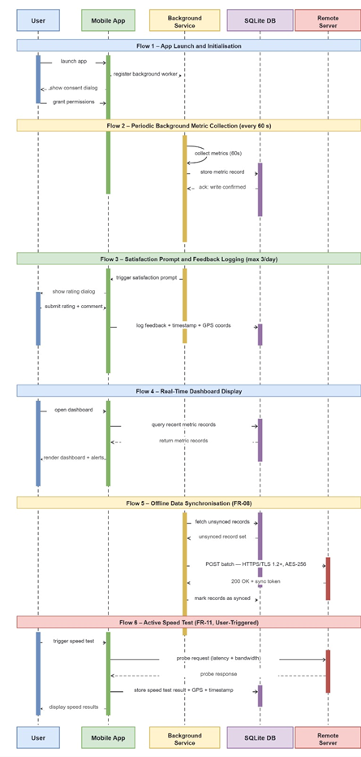
Figure 1: Sequence Diagram – QoE Mobile Network Monitoring Application (6 flows, 25 messages)

3.3. Sequence Diagram Flows
The sequence diagram is organised into six logical flows, each corresponding to a distinct use-case scenario. The flows are presented in the order they would typically occur during a full session of application use.

3.3.1 Flow 1: Application Launch and Initialisation
This flow covers the actions taken when the subscriber opens the application for the first time or after a restart. It establishes the background worker and obtains the necessary device permissions.
# | Actor (From) | Message / Action | Actor (To) | Notes
Flow 1 – App Launch and Initialisation
1 | User | launch app | Mobile App | User opens the application from device home screen
2 | Mobile App | register background worker | Background Service | App registers WorkManager (Android) / BackgroundTasks (iOS) for 60-second metric collection
3 | Mobile App | show consent dialog | User | App presents GDPR/ART-compliant data collection consent screen
4 | User | grant permissions | Mobile App | User grants location, network state, and background execution permissions. Without consent, FR-06 (GPS tagging) is blocked per NFR-02

3.2.2 Flow 2: Periodic Background Metric Collection
Once initialised, the Background Service operates continuously, collecting network and device metrics without requiring user interaction. This is the core passive data collection behaviour specified in FR-01.
# | Actor (From) | Message / Action | Actor (To) | Notes
Flow 2 – Periodic Background Metric Collection (every 60 s)
5 | Background Svc | collect metrics (self-call) | Background Svc | Reads: network type (2G/3G/4G/5G), signal strength (dBm), latency (ms), jitter, packet loss, bandwidth, GPS coordinates, timestamp
6 | Background Svc | store metric record | SQLite DB | Persists collected metric bundle with status = unsynced. AES-256 applied to GPS fields at rest
7 | SQLite DB | acknowledgement | Background Svc | Confirms successful write. Retry logic activated if write fails due to storage constraints

3.3.3 Flow 3: User Satisfaction Prompt and Feedback Logging
At defined intervals, the Background Service instructs the app to present a satisfaction prompt to the user. The user’s rating and optional comments are logged alongside a timestamp and GPS coordinates for contextual correlation with objective metrics.
# | Actor (From) | Message / Action | Actor (To) | Notes
Flow 3 – Satisfaction Prompt and Feedback Logging (max 3/day)
8 | Background Svc | trigger satisfaction prompt | Mobile App | Service fires a local notification or wakes the foreground activity to display the prompt
9 | Mobile App | show rating dialog | User | App presents Likert-scale satisfaction rating and optional comment field (FR-04, FR-05)
10 | User | submit rating + comment | Mobile App | User provides subjective QoE rating (e.g., 1–5 stars) and optional free-text comment
11 | Mobile App | log feedback + timestamp + GPS | SQLite DB | Feedback entry is stored with correlated objective metrics, GPS coordinates (if consent granted), and ISO 8601 timestamp

3.3.4 Flow 4: Real-Time Dashboard Display
The user may open the dashboard at any time to view current network metrics. The app queries the local SQLite database and renders the data without requiring a server connection, supporting offline usability.
# | Actor (From) | Message / Action | Actor (To) | Notes
Flow 4 – Real-Time Dashboard Display
12 | User | open dashboard | Mobile App | User navigates to the main dashboard screen (FR-02)
13 | Mobile App | query recent metrics | SQLite DB | App requests the most recent metric records for display. Query scoped to the last retention window
14 | SQLite DB | return metric records | Mobile App | Database returns metric bundle: signal strength, latency, network type, QoE score history
15 | Mobile App | render dashboard | User | App renders charts and indicators. Threshold alerts are highlighted if values breach defined limits (FR-03)

3.3.5 Flow 5: Offline Data Synchronisation
When network connectivity is restored after a period of offline data collection, the Background Service detects the change, retrieves all unsynced records from SQLite, and uploads them to the remote server in a batched request over a TLS-secured channel.
# | Actor (From) | Message / Action | Actor (To) | Notes
Flow 5 – Offline Sync When Connectivity Restored (FR-08)
16 | Background Svc | fetch unsynced records | SQLite DB | Service queries all records with sync_status = unsynced, ordered by timestamp ascending
17 | SQLite DB | return unsynced records | Background Svc | Returns batched result set of metric and feedback records pending upload
18 | Background Svc | POST batch (TLS 1.2+) | Remote Server | HTTPS POST with JSON payload. Headers include device ID, app version, and batch timestamp
19 | Remote Server | 200 OK + sync token | Background Svc | Server confirms receipt and returns a sync token for deduplication on retry
20 | Background Svc | mark records as synced | SQLite DB | Updates sync_status = synced for all uploaded records. Retention policy then governs deletion

3.3.6 Flow 6: Active Speed Test
The user may manually trigger an active speed test from the dashboard. The application sends a probe request to the remote server and measures latency and bandwidth, storing the result locally and displaying it immediately.
# | Actor (From) | Message / Action | Actor (To) | Notes
Flow 6 – Active Speed Test (FR-11, User-Triggered)
21 | User | trigger speed test | Mobile App | User taps the speed test button on the dashboard (FR-11 added during requirements analysis)
22 | Mobile App | probe request | Remote Server | App sends a controlled probe packet to the designated test endpoint to measure round-trip latency and download/upload bandwidth
23 | Remote Server | probe response | Mobile App | Server responds with payload sized for bandwidth measurement. Round-trip time computed on device
24 | Mobile App | store speed test result | SQLite DB | Result stored with timestamp and GPS coordinates for correlation with passive metrics
25 | Mobile App | display speed results | User | App renders download speed (Mbps), upload speed (Mbps), and latency (ms) on screen

3.4. Key Design Decisions Reflected in the Diagram

3.4.1 Offline-First Architecture
Every metric and feedback record is written to SQLite before any upload attempt. This ensures data integrity during periods of poor or absent connectivity, which is a realistic operating condition in Cameroon’s network environment. The Background Service manages the sync queue independently of the foreground application.

3.4.2 Consent-Gated GPS Collection
Flow 1 shows that consent must be obtained during initialisation before GPS coordinates are recorded. This is a direct implementation of the dependency identified in the requirements analysis: FR-06 (location tagging) depends on NFR-02 (data privacy and user consent). Without explicit consent, the application proceeds without GPS fields.

3.4.3 Background Execution Strategy
The Background Service uses platform-specific APIs because React Native does not natively expose a unified background execution model. WorkManager on Android provides guaranteed execution even when the app is closed; BackgroundTasks on iOS provides similar functionality within the OS-imposed energy constraints.

3.4.4 Prompt Frequency Enforcement
The Background Service enforces the maximum of three satisfaction prompts per day (FR-05 refined during inconsistency resolution). The counter is persisted in SQLite and checked before Flow 3 is triggered. It resets at midnight device local time.

3.5 Security
All communication with the Remote Server uses TLS 1.2 or higher (NFR security requirement). GPS fields stored in SQLite are encrypted using AES-256 at rest, consistent with the security protocols confirmed as feasible during the requirements analysis phase.

3.6. Requirements Traceability
The table below maps each sequence diagram flow to the functional and non-functional requirements from the validated SRS.
Flow | Requirements | Description
Flow 1 | NFR-02, NFR-07 | Consent collection and background worker registration satisfy privacy and security requirements
Flow 2 | FR-01, NFR-01, NFR-07 | Background metric collection every 60 s with AES-256 encryption and TLS in transit
Flow 3 | FR-04, FR-05, FR-06 | User satisfaction prompting limited to 3/day; feedback logged with GPS (consent-gated)
Flow 4 | FR-02, FR-03 | Real-time dashboard display with threshold-based alerts for degraded metrics
Flow 5 | FR-08, NFR-02 | Offline queue management with automatic retry and secure HTTPS batch upload
Flow 6 | FR-11 (added) | Active speed test added during requirements analysis to complete system coverage

3.7 Conclusion
The sequence diagram presented in this report provides a comprehensive account of the dynamic interactions between the five actors of the QoE Mobile Network Monitoring Application. The six flows cover the complete operational lifecycle of the system, from first launch through background collection, user feedback, dashboard display, offline synchronisation, and active speed testing.
Every interaction is traceable to a validated requirement from the SRS produced in Task 2. The design decisions encoded in the diagram the offline-first architecture, consent-gated GPS collection, platform-specific background execution, and TLS-secured uploads are consistent with the technical feasibility findings confirmed during the requirements analysis phase.
This sequence diagram serves as the primary dynamic model guiding the implementation phase. Development will follow the critical path identified in the dependency mapping: FR-10 (authentication) → FR-01 (background collection) → FR-02/FR-03/FR-08 (dashboard, alerts, sync) → FR-04/FR-09 (feedback, export) → FR-06/FR-05 (location, prompt frequency).

4. Class Diagram Analysis Report

4.1. Overview
The class diagram for the QoE Mobile Network Monitoring Application serves as the architectural blueprint for the system design phase. It translates the functional requirements and non-functional requirements identified in the analysis into a structural model of objects, attributes, and operations.

4.2. Core Components and Logic
The system's structure is designed to support the Critical and High-priority requirements identified in the analysis:
- Data Collection & Persistence: The MonitoringService acts as the engine for continuous background collection. It interacts with the StorageManager, which implements AES-256 local encryption and the Offline Queue to ensure zero data loss during connection interruptions.
- Privacy and Security: The User class encapsulates consentStatus and hashedDeviceID. This ensures that LocationData is only associated with a NetworkMetric if explicit consent is granted, satisfying ART regulatory compliance.
- User Interface & Feedback: The Dashboard class handles the real-time visualization of KPIs and historical charts. The Feedback class captures subjective QoE data, which is triggered occasionally to supplement objective network metrics.

4.3. Technical Constraints and Feasibility
The diagram accounts for specific platform limitations noted in the technical assessment:
- iOS Limitations: On iOS, the NetworkMetric class will handle null values for raw dBm, as public APIs only expose network type.
- Battery Efficiency: The MonitoringService is designed to be lightweight, utilizing the Android WorkManager and iOS BackgroundTasks frameworks to remain under the 3% per hour battery drain limit.

The proposed class diagram provides a robust foundation for development. By mapping dependencies such as the requirement that encryption must be integrated before the offline queue stores data the model ensures a secure, efficient, and functional implementation of the crowdsensing platform.

5. TECHNICAL DEPLOYMENT AND SYSTEM DEPENDENCY REPORT

5.1 System Architecture Overview 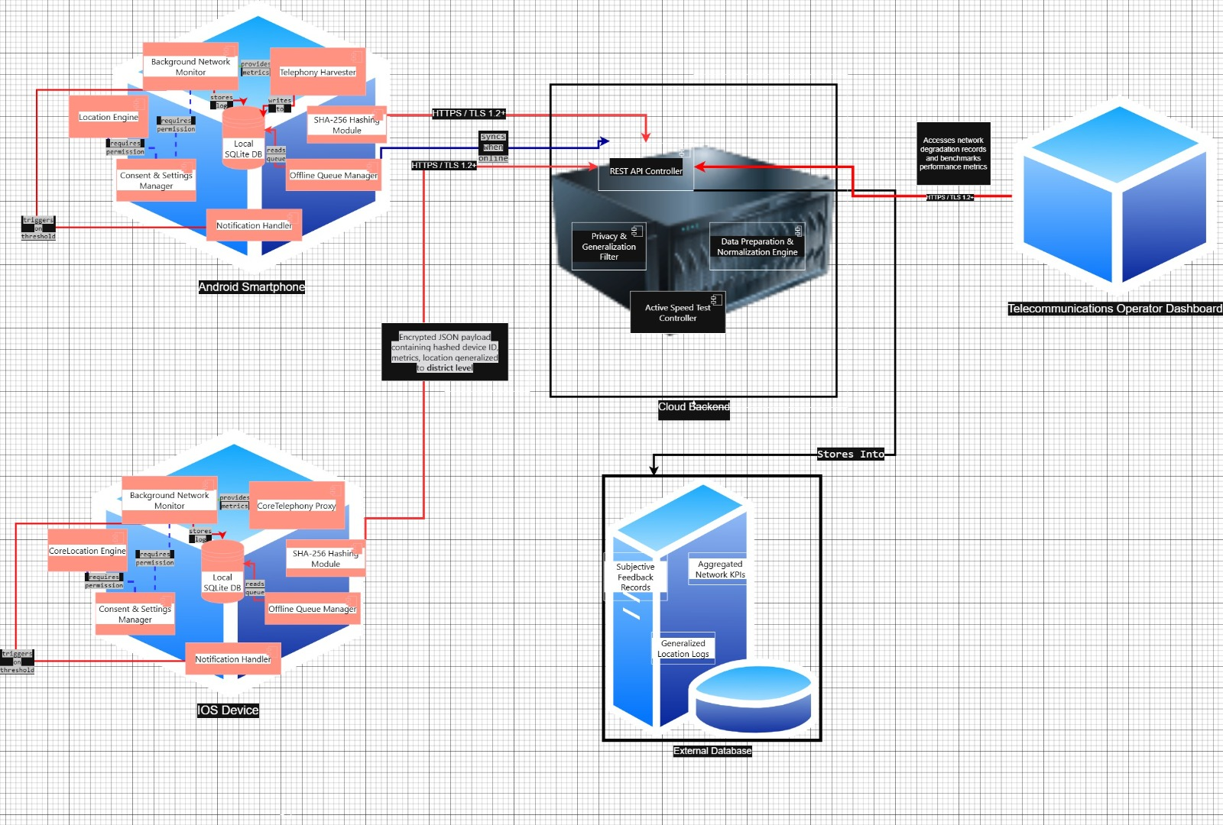

The system uses a four-tier architecture to collect, store, and display mobile network performance data (Quality of Experience - QoE) in Cameroon.

Tier 1 (Client Device Tier): The mobile applications installed on Android and iOS devices. They run background tasks, collect network metrics, and store data locally if the device is offline.

Tier 2 (Network Layer): The HTTPS protocol (Port 443) that securely sends data from the mobile devices to the cloud.

Tier 3 (Backend Server Tier): The cloud infrastructure consisting of an application server (Node.js) and a database server (PostgreSQL) to process and store the collected logs.

Tier 4 (External Stakeholder Tier): Web dashboards used by network operators (MTN, Orange) and regulatory bodies (ART Cameroon) to view the performance data.

5.2 Node configurations (what is inside each device)

A "node" represents a physical piece of hardware in our system. Below is exactly what components must be placed inside each node when drawing or setting up the system.

5.2.1 Node 1: Android Smartphone (OS 10+)

Software Environment: Android Runtime + React Native Engine.

Artifact: QoE_App_Android.apk (The actual app).

Consent & Settings Manager: Handles the setup screen where users give permission.

Background Network Monitor: The continuous background thread run by Android's "WorkManager".

Telephony Harvester: Collects raw signal strength metrics (RSRP, RSSI, SINR) from the SIM card.

Location Engine: Tracks coordinates using Android's "FusedLocationProviderClient".

Dashboard UI: The screen showing current network statistics.

Notification Handler: Triggers local push alerts when the network fails.

Identity Anonymization Module: Hashes device IDs on the client side using SHA-256 before storing them.

Offline Queue Manager: Coordinates saving data to the local database when offline.

Local Database: An encrypted SQLite database (using AES-256 encryption) that holds up to 7 days of logs.

5.2.2 Node 2: Apple iPhone (OS 16+)

Software Environment: iOS Native Sandbox + React Native Engine.

Artifact: QoE_App_iOS.ipa (The actual app).

Internal Components: Consent & Settings Manager which andles the iOS permission screen.

Throttled Background Fetcher: Manages periodic data collection using the iOS "BackgroundTasks" framework.

CoreTelephony Proxy: Collects signal bars and network generation type (4G/5G) instead of raw dBm signal strength.

CoreLocation Engine: Tracks device coordinates.

Dashboard UI: The user interface screen.

Notification Handler: Triggers iOS local alerts.

Identity Anonymization Module: Hashes device IDs on the client side using SHA-256.

Offline Queue Manager: Coordinates offline data storage.

Local Database: An encrypted SQLite database (AES-256) matching the Android offline queue.

5.2.3 Node 3: Cloud Application Server

Software Environment: Node.js / Express Web Server.

Internal Components: REST API Controller which handles background data uploads (/sync) and user data delete requests (/user/data).

Data Normalization Engine: Standardizes incoming names (e.g., changes "mtn", "Mtn", and "MTN" into "mtn").

Privacy & Generalization Filter: Truncates precise GPS coordinates to the district level before saving to comply with regulations.

5.2.4 Node 4: Central Telemetry Database Server

Software Environment: PostgreSQL Database.

5.3 Database Tables:

Aggregated Network KPIs: Stores RSRP, latency, and packet loss metrics.

Generalized Location Logs: Stores district-level location tags.

Subjective Feedback Records: Stores user ratings (1-5 stars) and comments.

5.3.1 System connection protocols (how nodes communicate)

5.3.1.1 Connection 1 (Mobile Devices to Cloud Application Server)

Protocol: HTTPS / TLS 1.2+

Connection Port: Port 443

Data Sent: An encrypted JSON payload containing hashed device IDs, metrics, and district-level coordinates.

Constraints: Uploads are limited to 5MB of background data per day to save user data bundles.

5.3.1.2 Connection 2 (Cloud Application Server to Database Server)

Protocol: PostgreSQL Protocol

Connection Port: Port 5432

Data Sent: Cleaned, validated, and normalized database entries,

5.3.1.3 Connection 3 (Stakeholder Dashboards to Cloud Application Server)

Protocol: HTTPS

Connection Port: Port 443

Data Sent: Secure requests to fetch anonymized coverage maps and signal charts.

5.3.2 Internal component dependencies (how the app parts work together)

Inside the mobile app, different parts must talk to each other. These are the logical dependencies you should map out:

The Consent Gate: The "Background Network Monitor" and "Location Engine" depend directly on the "Consent & Settings Manager". If a user does not give explicit consent, the collection engines must remain inactive.

The Data Harvester: The "Telephony Harvester" and "Location Engine" must write directly to the "Background Network Monitor" to pack network stats with spatial data.

The Offline Buffer: If the device loses internet connection, the "Background Network Monitor" must redirect all logs to the "Local SQLite DB" instead of trying to upload them.

The Security Wrapper: The "Local SQLite DB" must send data through the "Identity Anonymization Module" first to ensure that no raw user phone numbers or hardware IDs are stored in plaintext.

The UI Cache: The "Dashboard UI" reads its data directly from the "Local SQLite DB" cache every 2 seconds. This keeps the UI updated without draining the battery by running constant network tests.

The Trigger Pipeline: When the "Background Network Monitor" detects that the signal strength has dropped below -100 dBm, it automatically triggers the "Notification Handler" to alert the user and open a qualitative user survey.

5.3.2 Real-world system constraints

iOS Signal Strength Block: iOS does not allow third-party developers to access raw cell signal strength in dBm. The app must use qualitative "Signal Bars" as a workaround.

iOS Background Restraints: iOS stops background tasks quickly. Background collection will occur roughly every 15 minutes instead of continuously.

Offline Queue Caps: To protect the user's phone memory, the SQLite database queue is limited to 15MB or 7 days of logs. Once full, the app deletes the oldest logs first (FIFO).

Battery Protection: The background app must never consume more than 3% of the device's battery per hour.

6. Overall Conclusion
This report has presented the complete system modelling and design for the QoE Mobile Network Monitoring Application across six formally structured and mutually reinforcing models. Each model was constructed to answer a specific architectural question that the others could not answer alone, and together they constitute a full, internally consistent blueprint ready to guide the implementation phase of the project.

6.1 What Each Model Contributed
The Context Diagram established the system’s boundary with precision, identifying four external entities the Mobile Subscriber, GPS/OS APIs, Backend Server, and Telecom Operator and six named data flows crossing that boundary. It confirmed that the telecom operator receives aggregated coverage reports without any reverse interaction with the mobile app, correctly modelling the operator as a pure data consumer. The Level-0 and Level-1 Data Flow Diagrams then decomposed the system into five internal processes (P1–P5) and three on-device data stores (DS1–DS3). Every context diagram flow was verified to balance against corresponding DFD flows, and all functional requirements from FR-01 to FR-11 were mapped to at least one process, confirming that the data flow architecture is both complete and bounded.
The Use Case Diagram reframed the system from the actor’s perspective, cataloguing 24 use cases across 5 actors in 6 functional groups. Every use case is associated with at least one actor and justified by at least one requirement. The privacy architecture is visible directly in the diagram: three dedicated «include» use cases (UC18 Encrypt & Store, UC19 Anonymise Before Transmit, UC22 Generalise GPS to District) enforce data protection at the precise moments where data is written, transmitted, and located not as afterthoughts, but as non-skippable steps in the core functional paths. This directly reflects the most significant finding from the Task 2 survey: that 68.8% of Cameroonian smartphone users cited privacy as their primary concern about such an application.
The Sequence Diagram provided the only model capable of capturing the order of interactions across the system’s dynamic behaviour. Its six flows app launch and consent, background metric collection, user satisfaction prompting, real-time dashboard display, offline synchronisation, and active speed test trace the complete operational lifecycle from first installation to regular use. The diagram confirmed that the consent gate (Flow 1) must execute and be recorded before any GPS or metric collection is activated (Flow 2), establishing an immovable sequencing constraint that developers must respect. It also validated that the offline-first architecture correctly decouples data production from data transmission: metrics are written to SQLite in Flow 2 and uploaded in Flow 5, independently and asynchronously.
The Class Diagram translated the system’s functional and non-functional requirements into an object-oriented structural model, defining the classes, attributes, methods, and relationships that developers will implement directly in TypeScript. The MonitoringService drives the 60-second collection cycle under platform-specific scheduling constraints; the StorageManager wraps all database access with AES-256 encryption before any write; the User class encapsulates consentStatus and hashedDeviceID as its core identity fields, ensuring that LocationData is only associated with a NetworkMetric when consent has been explicitly granted. The MVVM architecture is clearly expressed through the Dashboard class reading from the StorageManager cache every two seconds, keeping the display cycle independent of the 60-second collection cycle. The diagram also confirmed the feasibility assessment from Task 3: the NetworkMetric class handles null dBm values on iOS gracefully, returning network type where the platform API restricts access.
The Deployment Diagram grounded the system in its physical infrastructure, mapping software components across four concrete tiers: two mobile device nodes (Android and iOS), a cloud application server running Node.js, and a central PostgreSQL database server. It specified every communication protocol and port HTTPS/TLS 1.2+ on port 443 for mobile-to-server traffic, the PostgreSQL protocol on port 5432 for server-to-database traffic, and HTTPS on port 443 for stakeholder dashboard access giving the DevOps team everything needed to configure the network and security infrastructure. The diagram also made explicit the real-world constraints that will affect operation in Cameroon’s environment: iOS’s 15-minute background task frequency limit, the 15 MB / 7-day offline queue cap, and the 3% per-hour battery consumption ceiling.

6.2 Cross-Cutting Design Themes
Reading across all six models, four design themes emerge consistently. First, offline-first data integrity: every model from the DFD’s DS3 Upload Queue to the Sequence Diagram’s sync flow to the Deployment Diagram’s queue cap ensures that no metric record is ever lost, regardless of network availability. This is the primary technical response to Cameroon’s network coverage reality, confirmed by the Task 2 survey finding that 94% of respondents encounter network problems regularly. Second, privacy by design: AES-256 encryption, SHA-256 device ID hashing, district-level GPS generalisation, and granular consent gating appear as concrete implemented mechanisms in the Class Diagram and Sequence Diagram, not as vague policy statements. Third, platform-aware cross-platform deployment: every model acknowledges the Android/iOS divergence WorkManager vs. BackgroundTasks, TelephonyManager vs. CoreTelephony, dBm vs. signal bars rather than abstracting it away. Fourth, separation of concerns: collection, display, notification, feedback, and synchronisation are independent processes in the DFD, independent use case groups in the Use Case Diagram, independent lifelines in the Sequence Diagram, and independent classes in the Class Diagram. This consistency means any one component can be modified, tested, or replaced without cascading changes across the system.

6.3 Requirements Traceability
Every functional requirement from the validated SRS produced in Task 3 is traceable to at least one element in these six models. The eleven functional requirements (FR-01 to FR-11) and the non-functional requirements governing security, privacy, performance, and reliability (NFR-01 to NFR-09) each appear explicitly in the requirements traceability tables embedded within each section of this report. The three inconsistencies and six ambiguities identified during the Task 3 analysis phase have all been resolved through explicit design decisions: Ambiguity I-02 (undefined notification thresholds) is resolved by the ThresholdConfig class and UC16; I-03 (no notification frequency limit) is resolved by the 3-per-day cap in UC3 and the Sequence Diagram’s prompt counter; I-06 (missing data deletion mechanism) is resolved by UC10 and the User class’s deleteData() method. The design is therefore not only complete but also self-consistent with the analysis phase that preceded it.

6.4 Implementation Readiness and Next Steps
The system is now ready to proceed to implementation. The dependency mapping identified in the Sequence Diagram confirms the critical development path: authentication and consent infrastructure (FR-10, NFR-02) must be built first, as it gates all subsequent collection; the background collection service (FR-01) must be operational before any dashboard, notification, or sync feature can be tested end-to-end; the offline queue and sync manager (FR-08) must be stable before the backend reporting pipeline (FR-07) is connected. Following this dependency order across four implementation sprints Foundation, Core Collection, User Interface and Backend, and Operator Portal will ensure that each increment delivers testable, demonstrable value and that no sprint is blocked by an incomplete upstream component.
The QoE Mobile Network Monitoring Application is a technically demanding system operating under real-world constraints intermittent connectivity, strict privacy regulation, two divergent mobile platforms, and resource-constrained hardware that are documented facts about the Cameroonian mobile network environment, not theoretical concerns. The six models produced in this report encode those constraints directly. The result is a design that is not merely theoretically correct but practically deployable: grounded in survey evidence from 93 Cameroonian respondents, traceable to validated requirements, and detailed enough to be handed directly to a development team as the primary implementation reference for the QoE Mobile Network Monitoring Application.

